Prof. Ram Meghe College of Engineering & Management, Badnera- Amravati
Department of Computer Science & Engineering
Practical Journal (Summer 2026)
Practical No.: - 8
Aim: Introduction to Source Code Management and Installation of Git.
Theory:-
What is Source Code Management?
Source code management is like a digital filing system for computer code. It helps developers work together on projects by keeping track of changes they make to the code. It saves different versions, lets people work on separate parts at the same time, and shows who did what and when. Popular tools include Git, which makes it easy to manage code changes and collaborate with others.
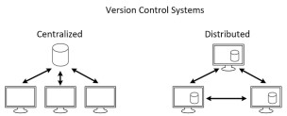
There are mainly two types of source code management: centralized and distributed. 1.
Centralized Source Code Management: In this type, there is a central server that stores the code repository, and developers check out code from this central location to work on it.
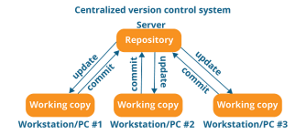
2. Distributed Source Code Management: A distributed version control system (DVCS) brings a local copy of the complete repository to every team member’s computer, so they can commit, branch, and merge locally.
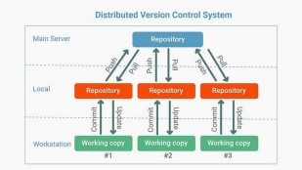
What is Git?
Git is a popular version control system. Version control, also known as source control, is the practice of tracking and managing changes to software code. Version control systems are software tools that help software teams manage changes to source code over time. It keeps track of every modification to the code in a special kind of database. If a mistake is made, developers can turn back the clock and compare earlier versions of the code to help fix the mistake while minimizing disruption to all team members.
Git was created by Linus Torvalds in 2005, and has been maintained by Junio Hamano since then.
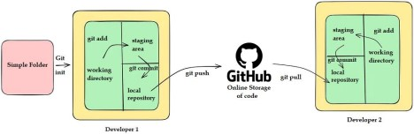
Git Workflow
Key Git Concepts
∙ Repository: A folder where Git tracks your project and its history.
∙ Clone: Make a copy of a remote repository on your computer.
∙ Stage: Tell Git which changes you want to save next.
∙ Commit: Save a snapshot of your staged changes.
∙ Branch: Work on different versions or features at the same time.
∙ Merge: Combine changes from different branches.
∙ Pull: Get the latest changes from a remote repository.
∙ Push: Send your changes to a remote repository.
What is Git Repository?
A Git repository (or repo) is a storage space where your project’s files and their complete history of changes are kept. It allows you to track, manage, and collaborate on code over time.
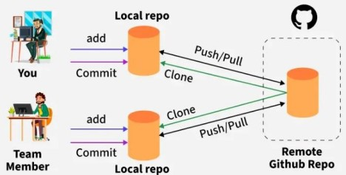
There are two types of Git repositories as shown above:
- Local Repository
∙ Stored on your own computer.
∙ Allows you to make changes, commit them, and review your project history without needing an internet connection.
∙ Example: The .git folder inside your project contains the local repository.
- Remote Repository
∙ Hosted on a server like GitHub, GitLab, or Bitbucket.
∙ Enables multiple developers to collaborate on the same project.
∙ Supports operations like push, pull, and fetch to synchronize changes with the local repository.
How does Git work?
Git stores your files and their development history in a local repository. Whenever you save changes you have made, Git creates a commit. A commit is a snapshot of current files. These commits are linked with each other, forming a development history graph, as shown below. It allows us to revert back to the previous commit, compare changes, and view the progress of the development project
Working with Git
∙ Initialize Git on a folder, making it a Repository.
∙ Git now creates a hidden folder to keep track of changes in that folder. ∙ When a file is changed, added or deleted, it is considered modified.
∙ You select the modified files you want to Stage.
∙ The Staged files are Committed, which prompts Git to store a permanent snapshot of the files.
∙ Git allows you to see the full history of every commit.
∙ You can revert back to any previous commit.
∙ Git does not store a separate copy of every file in every commit, but keeps track of changes made in each commit.
Installing Git on Linux
1. Open your terminal and use your package manager. For example, on Ubuntu:
$ sudo apt-get update $ sudo apt-get install git 2. Verify the installation was successful using the command:
$ git –version
3. Configure your Git username and email using the following commands, replacing “Your_name” with your own name and “youremail” with your email id. These details will be associated with any commits that you create:
$ git config --global user.name " Your_name "
$ git config --global user.email " youremail @abc.com"
Installing Git on Windows
1. Download the latest Git for Windows installer from https://gitforwindows.org/. 2. When
you've successfully started the installer, you should see the Git Setup wizard screen. Follow the Next and Finish prompts to complete the installation. The default options are pretty sensible for most users.
3. Open a Command Prompt (or Git Bash if during installation you elected not to use Git from the Windows Command Prompt).
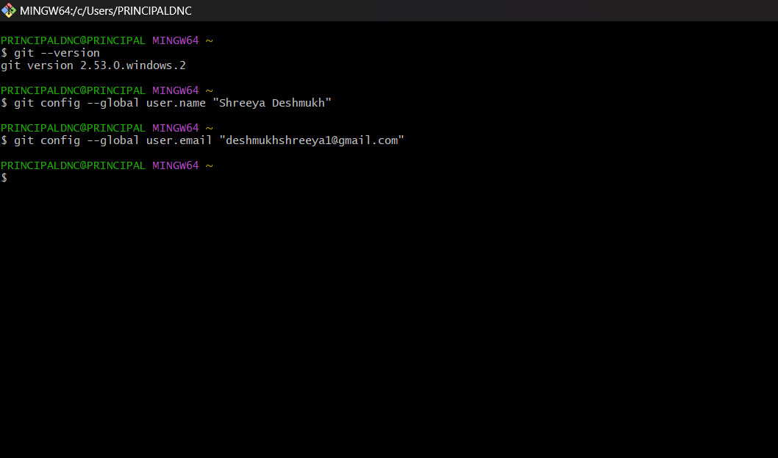Run the following commands to configure your Git username and email using the following
commands, replacing “Your_name” with your own name and “youremail” with your email id. These details will be associated with any commits that you create:
$ git config --global user.name " Your_name " $ git config --global user.email " youremail @abc.com"
Conclusion:
Thus we have successfully understood the concept of Source Code Management (SCM) and installed and configured Git.

